**printingtelegraphy**

**Printing Telegraphy**

**A Data Communication Historical Series**

**By Bob Pollard**

**Printing Telegraphy and Teletypewriters (1902-1980):**

The terms ‘Telegraph or Telegraphy’ were the original designations for the early devices that could send / receive messages. These were fairly crude devices and usually received signals that were composed of dot and dashes, which were then translated into characters and/or deciphered by an individual and then recorded. Following this period of character printing Telegraphy and printing Telegraph devices the terms Teletypewriter, Teletype, TTY and Tele-printer were used interchangeably for a Teletypewriter device, which was the equivalent of an on-line electric typewriter with additional features. Later along came the Cathode Ray Tube (CRT) display terminal, which, later, was referred to as a ‘Monitor’. And then the terminals became whatever one desired since they were programmable or could be a complete computer system.

As early as 1902 Frank Pearne experimented with a direct character printing telegraph system and during the period of 1902-1907 Charles and Howard Krum was able to test an experimental character printer on a telegraph line. The typing portion of this machine was a modified Oliver typewriter with the necessary relays, contacts, magnets, and interconnecting wires; the Krum’s continued their experiments with a view to developing a direct keyboard type wheel printer.

They also sought most of all to figure out a method of synchronizing the transmitting and receiving units so that they would stay ‘in step’. It was Howard Krum who worked out the start-stop method of synchronization. Also, the sending device and receiving device motor speed had to be operated at the same RPM (Revolutions per Minute) in order to maintain correct translation of the characters.

A Morkrum printing telegraph unit in 1911 used a form of synchronous operation that required the transmitting and receiving devices to function at exactly the same speed. In the Morkrum system the receiving mechanism is adjusted by a governing rheostat in order to keep the transmitted and received signals in phase. The receiving mechanism included relay and selection locks that sampled the signal for a short duration at predetermined intervals. This phasing and speed control with line sampling intervals read each character in proper order. Some distortion and power fluctuations could be corrected by the main line relay, which was part of the receiving mechanism, and this would provide some stability. All this happened at low speeds and was somewhat reliable if the receiving mechanism could be kept in phase with the sending device.

The transmitters first used by the Krum’s were of the continuously moving tape variety; a slow speed device. A stepped tape feed, they maintained, would even reduce transmission speed more.

Keyboard controlled cam-type start-stop permutation code transmitters were developed by Charles and Howard Krum in about 1919. This transmitter employed a single contact to open or close the signal line.

Kleinschmidt was also interested in a start-stop-permutation code telegraph system. The system he developed employed the start-stop principle with a modified version of his earlier multiplex distributor. The Morkrum Company and the Kleinschmidt Electric Company eventually merged, and at a later date the company became the Teletype Corporation.

In 1921 the M11 type-wheel tape printer, went into production. It constituted the first commercially acceptable and successful unit. The M11 was manufactured through 1927. The name ‘Teletype’ was introduced as part of the advertising promotion for the Model 11 machine.

1922: The M12, a type-bar page printer with moving platen, was first marketed. The M12 page printer opened the way to general business uses. A substantial number of this unit were sold, with some being sold up to the early 1940s.

1925: The M14 type-bar tape printer was produced. The printer reached its highest production in 1929 and 1930 and was discontinued in the late 1950s.

Teletype merged into the Bell System in 1930. From this point on, advances in the Teletype product were a result of the pooled efforts of the AT&T Company, the Western Electric Company, and the Teletype Corporation.

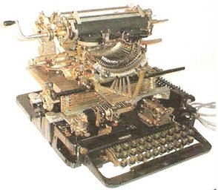

1930: Teletype Corporation Model 15 Page Printer

In the early years, about 1874 forward and prior to 1963, the most used code set for teletypewriters was the five-bit (Baudot / Murray or variations: ITA2 and USTTY) code. Asynchronous operation requires a start and stop bit be added to each five-bit character, then the character becomes a 7 to 7.5-bit character. Some machines required a 1.5 stop bit.

The transmitting and receiving mechanism for teletypewriters or for a transmitter-distributor, in simple terms, would appear as illustrated in Figure 1-1. The distributor function for transmitting the bits, serially, is internally located within the Transmitter or Teletypewriter machine. Figure 1-1 could represent a keyboard or transmitter on the left and a printer or receiving tape punch on the right.

A simple teletype circuit is shown below. The teletypewriter is represented by its transmitter contacts and its receiver electromagnet. A typical teletypewriter circuit has a current of about 60 milliamps, with a 110 VDC source; circuit-left: split with 55V each end of the circuit. Adjustable resistances were usually used to adjust the current to the proper value. For short distances 20 milliamps was satisfactory.

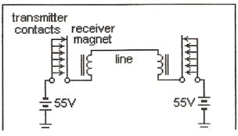

Figure 1-1

Mechanically a keystroke, such as the letter ‘A’, would close contacts 1 and 2 and leave contacts 3, 4 and 5 open. The same keystroke would release the distributor shaft clutch allowing the shaft to turn and transmit the character bits in series to the receiving distributor. The sending and receiving units must be synchronized in order to function properly and if they are mechanically tied together this is not a problem. If the sending and receiving devices are located some distance from each other than some method of synchronization is required. The ‘start’ and ‘stop’ bits solve the synchronization problem. Prior to sending the first ‘1’ bit (contact 1), in the above example, a space bit is transmitted.

This space bit becomes the ‘start’ bit and triggers the shaft clutch at the receiving end. When the shaft rotates, at the same speed as the sending device shaft, it correctly deciphers the received five bits. At the end of the five-character bits is a mark bit (stop), which locks the shaft clutch and the shaft stops, awaiting the next space bit (start). This synchronization requirement causes the five-bit code to become a 7-bit code, or in some cases 7.5 bits where a longer stop bit is needed. The receiving device would normally print the characters as they are received at the designed WPM (Words per Minute) rate of the device, which implies that the sending and receiving device must operate at the same WPM rate. No ‘ink jet’ or ‘laser’ printer capability was available in those days, only the typewriter ribbon. In the beginning and for many years 50, 60 to 75-WPM was the norm. In later years 100 and 150-WPM Teletypewriter devices were in service. Words per Minute are calculated on the basis of 6 characters (5 plus a space) for each word.

The clutch mechanism in the earlier teletypewriters was composed of two metal discs with a felt or leather disc, under pressure, between the two metal discs. One of the metal discs was mechanically coupled to the motor, with the other metal disc coupled to the typing mechanism. The felt/leather disc required frequent oiling to prevent burnout or lockup since it was located between a spinning disc and a stationary disc. The clutch mechanism when triggered by the start bit would allow the typing mechanism disc to start spinning at the same speed as the motor side disc, and in turn the character bits would be deciphered. In reference to the disc on the typing mechanism side, the same theory would apply for a keyboard, receiving printer or receiving perforator.

In later Teletypewriter models the Clutch mechanism uses a direct mechanical engagement to lock the two discs together. In simple terms the clutch would work in the following manner. The motor side disc has a flat ring around the disc that has a series of grooves spaced all the way around inside the ring. The stationary side uses friction pawls, that when released by the start bit, would mechanically engage the rotating ring on the motor side. This resulted in the stationary send-keyboard or receive-printer side disc spinning at the same rate as the motor disc, and in turn allowed the sending or receiving (deciphering) of the character bits. The grooves on the spinning ring allowed the dust caused by the friction pawls to be sloughed off.

In 1951 the first M28 page printer was produced. The M28 design principle continued for both message and data recording equipment until 1960.

In 1963-1965 the M35 and M33 lines of equipment were introduced. The M35 is an 8-level version of the M28. The M33 a new design could be described as a ‘low cost concept’. Operational specifications for these Teletypewriter / console units are listed in Figures 1-3, 1-4 and 1-5.

Terminal; transmit and receive selection:

All early Morse code and Teletype communication activity occurred on a point to point basis. There were two basic methods of connecting offices together. In one instance Office ‘A’ would be connected directly to Office ’B’ with no other offices on the line. The other method was to connect more than two offices on a line in a serial manner. As stated earlier, all offices on the line would receive any and all the messages transmitted by any office on the line.

Figure 1-2 is a simple diagram of three teletypewriters connected in series on one line. The three teletypes could be many miles apart or located locally within one city or office. As illustrated when one keyboard is activated all the printer units of all three teletypes will print the triggered characters. KBD = Keyboard and PRTR = Printer.

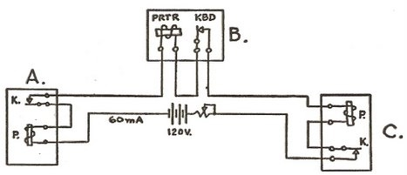

Figure 1-2

One of the first terminal receive selection features installed in the Teletypewriter utilized selector bar mechanisms in order to select only one terminal on the line at a time. This feature is covered briefly in the Multi-point Terminal connections section.

Most of the earlier teletype equipment, from about 1874 up to 1963 used the ‘five-level’ Baudot / Murray code or the ITA2 (International) or the USTTY (U. S.) code, which were variations of the Baudot / Murray code. The characters and symbols were encoded in a combination of five positive or negative pulses (1's or 0's); these could also be punched into paper tape and transmitted via a paper tape transmitter (transmitter-distributor).

Later (after 1963) teletypewriter equipment utilized the American National Standard Code for Information Interchange (ANSCII), using a paper tape wide enough to accept seven- or eight-bit positions. The ANSCII code provided for parity checking (8th bit position), and thus had an error detection capability, which allowed the receiving device to reject an entire message if an error was detected in any character. The acronym ANSCII was later changed to ASCII, American Standard Code for Information Interchange, due to revisions in the code.

Modern Teletypewriter terminals and other types of terminals using a special control box (unit), 1950’s forward, had many different operational features or ‘modes’ of operation. Examples of these different modes of operation, based on terminals used for military purposes, are described in the following paragraphs. These same modes of operation, among others, would also be used for civilian purposes.

Synchronous Mode Terminal:

Synchronous duplex (full duplex) transmission using the ASCII eight-bit (seven data bits plus parity) code set. The transmitted bit stream is synchronized by utilizing the ASCII sync character(s). Other synchronous control characters are used for idle line conditions. A start or stop bit is not used since the connected terminals do not utilize a clutch mechanism or any other start-stop triggering requirement. Various data code elements, such as ASCII, Hollerith punched card, magnetic tape, computer generated data, facsimile, etc. can be transmitted / received after it has been converted to the ASCII odd parity code. Control characters are used to maintain the proper data protocol and control.

With a fully controlled operation, both sending and receiving devices have the ability to stop the transmitting unit. In addition, both character parity (odd for data, even for control and framing) and horizontal parity is used to guard against errors during data transmission in ‘line-blocks’. Each line block for this terminal is comprised of 80 data characters (original IBM card format) and four block framing characters, two on each end. The first framing character is a Start of Message (SOM) for the first line block of a message, and Start of Text (STX) for subsequent line blocks. The second framing character is a DELETE character in terminal transmission and a security character on trunk transmission between switching centers. The third framing character is an End of Text (ETX) for all line blocks except the last, where an End of Message (EOM) to indicate end of transmission (message). The last framing character is used for error detection. The error correction process is initiated by the receiving device through the transmission of a Non-Acknowledgment (NAK) for a line block in which an error was detected. Only the line block containing an error need be re-transmitted by the transmitting device.

Asynchronous Mode Teletypewriter Terminal:

This operation would involve either a controlled or an uncontrolled asynchronous teletypewriter with full duplex capability. A start (space) bit and a stop (mark) bit are required. Each character transmitted begins with a start bit and ends with a stop bit. The start bit is usually one bit long (duration) and the stop bit is from 1 up to 2.0 bits long. Therefore an 8-bit ASCII code character would become a 10 to 11-bit character. The Baudot (modified) character would become a 7 to 7.5 (7.42) bit character. Depending on the equipment configuration this terminal may use the Baudot (ITA2 / USTTY) or ASCII code set. In the uncontrolled mode there is not any control over the sending or receiving functions. The transmission of data may begin at any time and the receiving equipment must be in an operational mode and ready to receive at all times. This mode of operation utilizes no error detection other than the use of channel (message) sequence numbers to guard against lost messages. In a controlled mode the terminal must be selected prior to sending or receiving.

Uncontrolled Terminal:

An uncontrolled Teletype means it operates without any controls that determine when it will send or receive. An operator could start transmission of a message at any time, whether the receiving device was ready or not. In order to avoid lost messages a start of message (SOM) and an end of message (EOM) sequence, along with message sequence numbers, are used. A typical SOM would be "ZCZC" and an EOM would be "NNNN". This would allow the receiving operators (device) to insure they received a complete message, although, errors could be present in the body of the message. It’s not a problem when an uncontrolled terminal is connected to a Message Switching Center because the Center equipment is always in a receiving state and prepared to accept the messages. Also, a group (2 or more) of uncontrolled terminals could be left in a receiving mode at all times and could receive messages whenever the messages were transmitted from some other terminal or from the switching center.

If message switching is not a requirement then the data start and end Identifier (I D) could be a one-character symbol for the beginning and one for the end, with the sender ‘I D’ character(s) at the beginning or end of the data. An Inquiry – response system would operate in this manner and not require the message format used in message switching systems.

An uncontrolled terminal could become a controlled terminal by adding the necessary protocol and line control equipment. In this environment the terminal would be ‘called’ by the Message Switching Center using Terminal selection characters for receiving a message or “polled’ by the Message Switching Center using different Terminal selection characters that allow the terminal to send a message.

Teletypewriters:

Figure 1-3 - M33 Teletypewriter Terminal, Figure 1-4 - M35 Teletypewriter Terminal and Figure 1-5 - M37 Teletypewriter Terminal provides examples of the technological advances in the development of the Teletypewriter terminals through the 1960’s. The terminals went from a simple non-controlled terminal to controlled terminals with many features. Such as, Baudot (and variations) code to the ASCII code, paper tape perforators (punch), paper tape transmitters, paper tape reels for tape take–up and storage, Control units (black box) for line / message protocol, error checking, calling and polling features and the standard keyboard and page printer.

The general name used for the M33, M35 and M37 Teletypewriter is ‘ASR’ (Automatic Send and Receive) unit.

Examples of the Baudot and the International 5-bit code are shown below. The ASCII code used a seven-bit code with an 8th bit for parity and would create a punched tape with 7 or 8 bits across the tape.

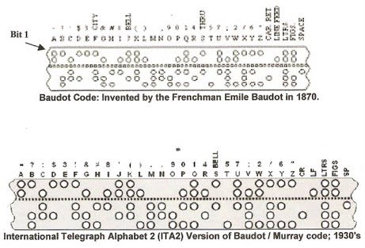

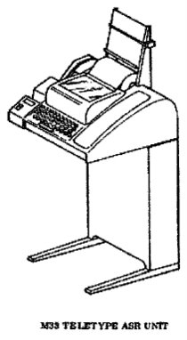

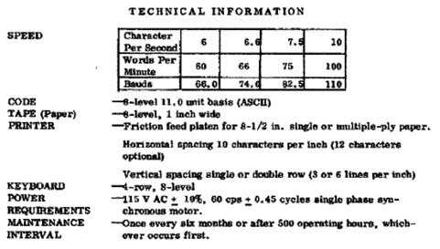

Figure 1-3

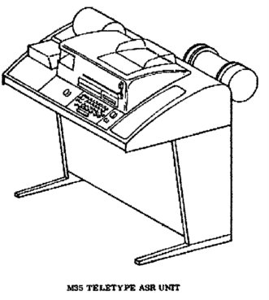

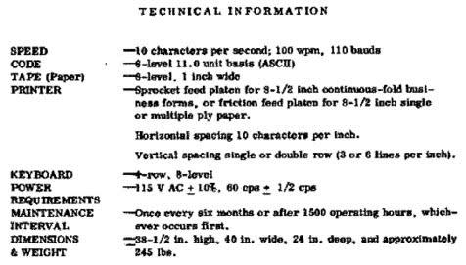

Figure 1-4

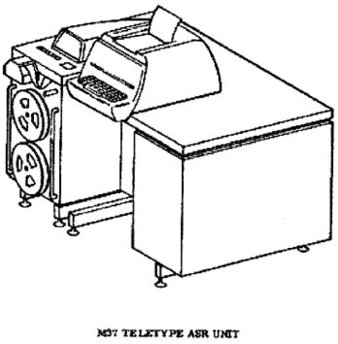

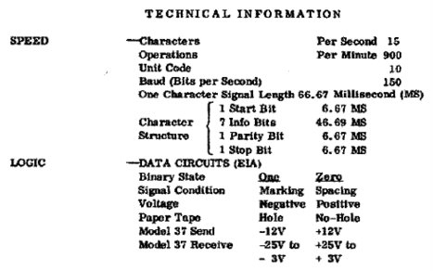

Figure 1-5

Cathode Ray Tube (CRT) Terminal:

The Cathode Ray Tube (CRT) Terminal arrived on the scene in the middle 60’s. The CRT terminals, through the associated control unit, operated in the synchronous mode and at a higher bit per second (bps) rate than the Teletypewriter. Normally a printer was assigned to a terminal or a group of terminals. The CRT, other than being large in size, isn’t much different than the Monitor used with the present Personal Computer (PC).

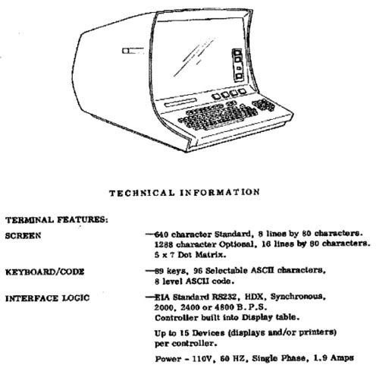

A couple of other terminal configurations:

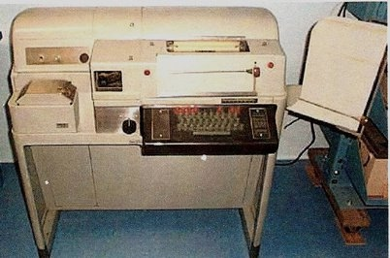

Model 28 ASR-2A; introduced around 1951 and widely in use through the 1980s; ASR: Automatic Send & Receive: Includes keyboard, page printer, paper tape perforator, transmitter and selection controls.

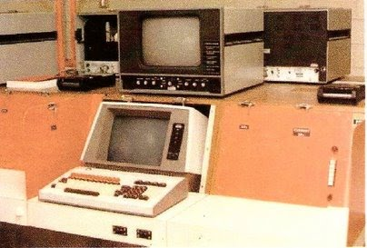

1960s Western Union equipment installed at the FAA Air Traffic Academy, used for pilot weather training. The unit on top is a closed-circuit TV set for viewing weather charts.